Story

The Necromancer (Hecate) has awakened and has created her armies of evil. At this point in time Humans are the rulers of Zanik. You wake up as the only survivor within your army and must complete your quest to defeat Hecate. On your way to Hecate you will have to defeat armies of monsters

Character

Main character – Soter(Greek word for saviour)

The Player is a large man with a heavy hit. Able to crush monsters with a mighty blow from his sword. As the player you will be able to move around in a 2D world and fight monsters.

Level

Level one contains a few different challenges with an easier start to get the player used to the game. Such as moving platforms that require timing to make the jump between and static platforms. At this stage if you fail you climb back up and try again unlike later in the level. There is trapdoors and doors you must unlock to progress by retrieving the pies this will also unlock a checkpoint on the pie location. It will contain some false walls the player can use to gain an advantage by gaining items and power ups. As you move though the level it will get harder and towards the end a bad jump could be fatal with the player landing in the magma.

Level two is a harder and more punishing that level one. It involves more jumping but focusing on vertical and curved jumping than horizontal like the first level. Timing is more critical on this level.

Overall, both levels contain jumping platforms, static platforms, hidden rooms and locked doors. They will contain a variety of demon spawns and weapons with different abilities.

Environment design

The game will be based in Hell so chains, magma, rocks and an underworld feel to it. It should put the player on edge and make them a little more alert. As you move more though the levels the game should get harder to match the player getting used to it. This is to always provide a challenge to the player.

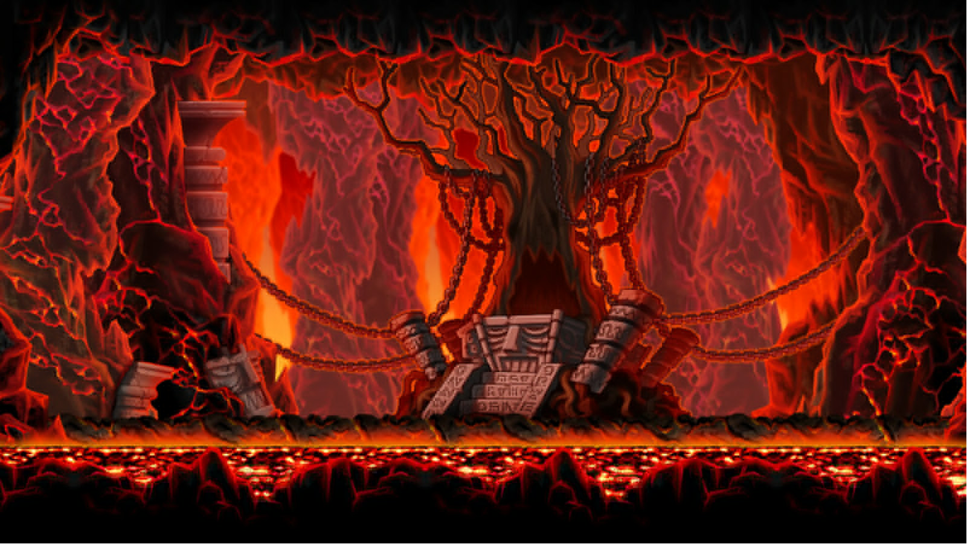

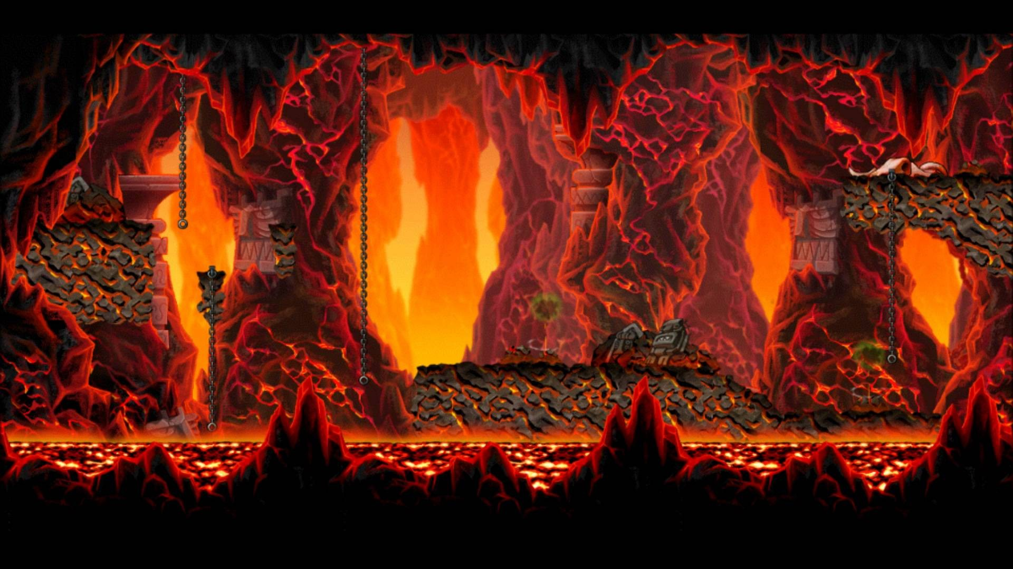

Game play

The game is a 2D platformer this will involve moving though a level of platforms static and dynamic. The player will start at one end of the level and will have to make their way to the other end. The character is a pie connoisseur, so he is after the secrets of hell to always have a perfectly cooked pie no matter how hot it is. To accomplish this, he will go in and steal the pies in hell.

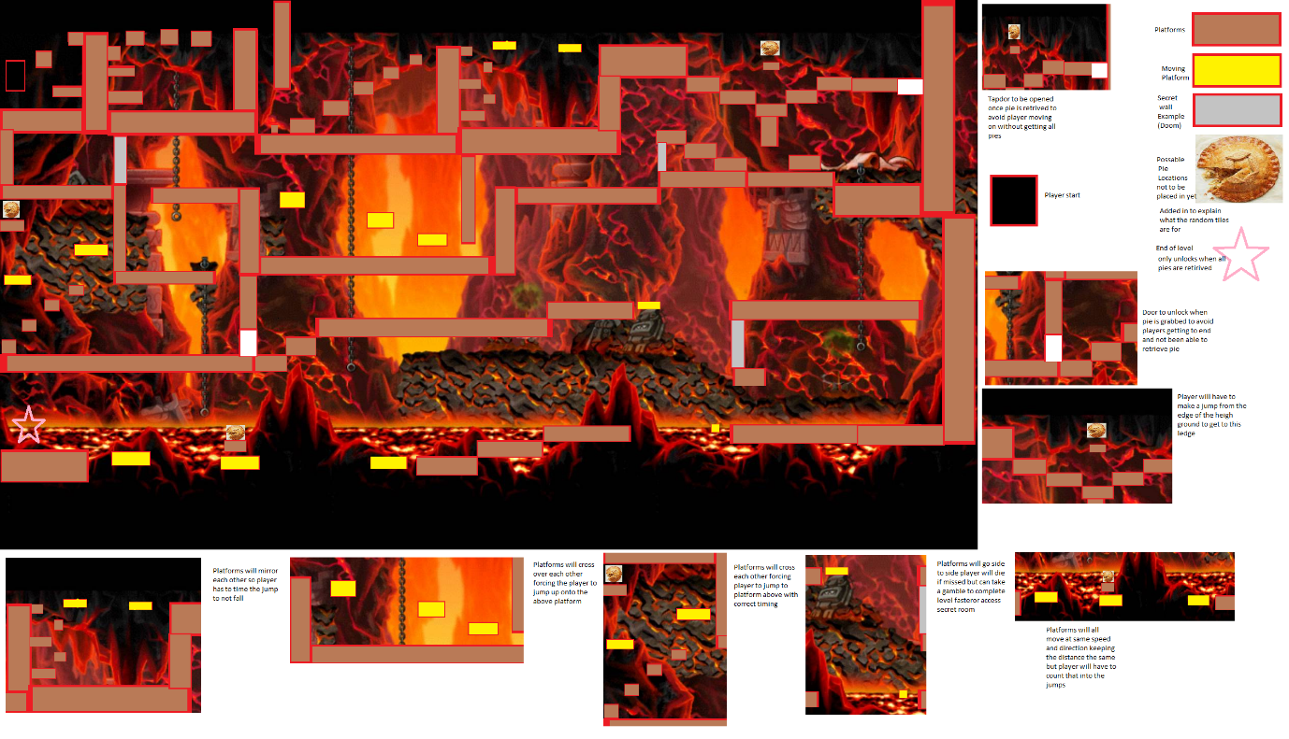

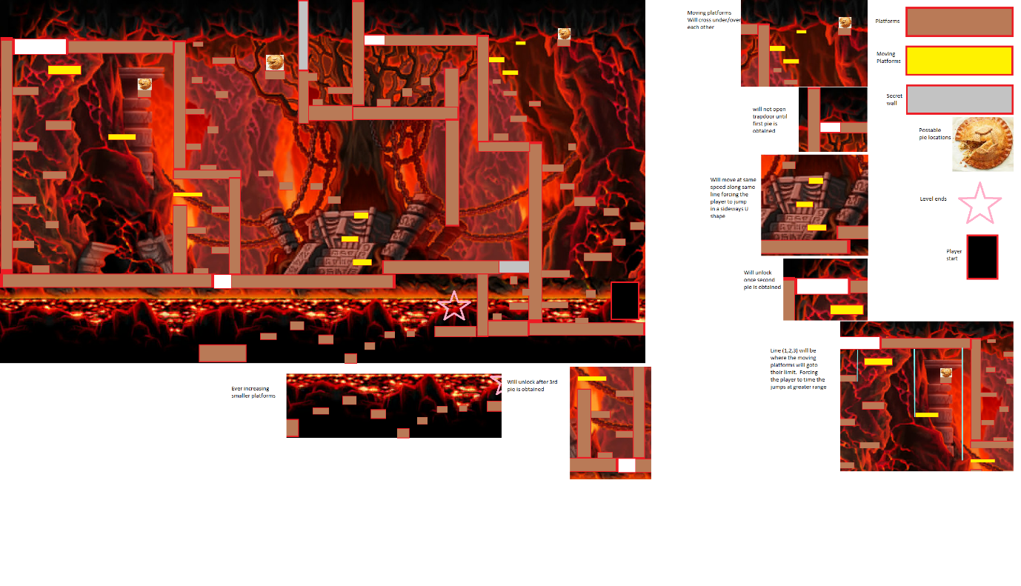

Art

The player will have animation for movement, jumping and shooting. The colour of the platforms will be brown and red for static while dynamic will be yellow and red. The secret rooms will look just like normal walls. Locked doors will have their own look to correspond with pies. The level will be visually easy to see and colour scheme fits in the hell theme well.

Sound and music

Music will be electric and designed to help put the player on edge to add the hell scheme that you should not be there, and it is dangerous. There will be sound queues for picking up pies and items/powerups.

List of music so far  
NoteDefender - Gundatsch

https://opengameart.org/content/note-defender-menu

Menu music

Inner Core - Gundatsch

https://opengameart.org/content/inner-core

https://creativecommons.org/licenses/by/3.0/

Level 1

Misanthropy - Gundatsch

https://opengameart.org/content/misanthropy

Level 2

sfx_pick(Pickup_item) - Blender Foundation

https://opengameart.org/content/pick-up-item-yo-frankie

coin(pie pickup) - Fupi

https://opengameart.org/content/plingy-coin

Death - Doom

http://www.wolfensteingoodies.com/archives/olddoom/sounds/dspldeth.wav

Powerup - Doom

http://www.wolfensteingoodies.com/archives/olddoom/sounds/dsgetpow.wav

Secret_Room - Doom

http://www.wolfensteingoodies.com/archives/olddoom/sounds/dspstart.wav

User interface and game controls

Below is the idea of the HUD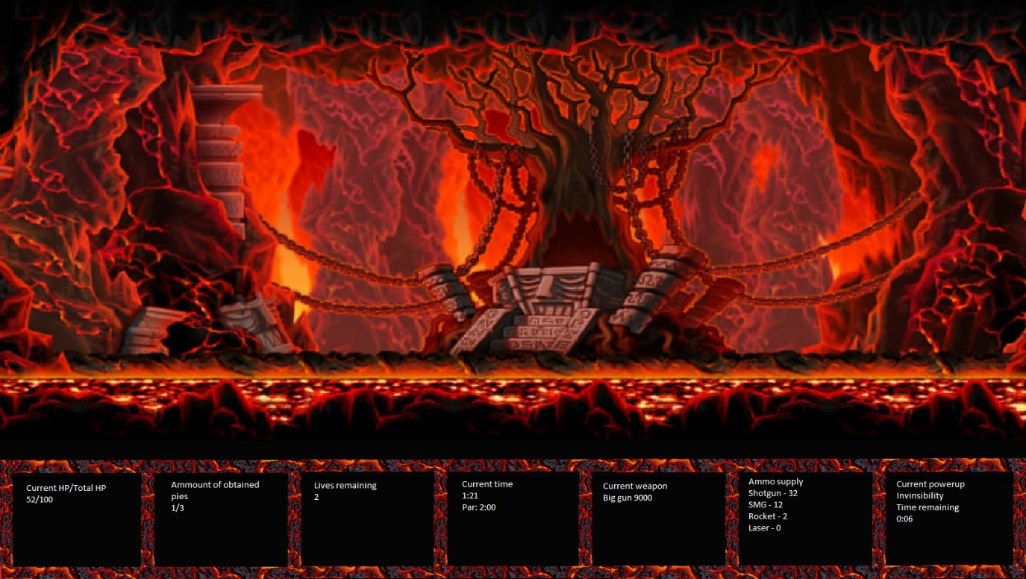

Key bindings

Jump – spacebar

Left – Left arrow key

Right – Right arrow key

Shoot – X

Weapon switch – q/w (scroll method)